Project Deliverable 3 Proposal

Andrew Witherite, Waylon Wu

IST261

1. Describe in detail all new and changed functionality your team intends to implement for project deliverable 3.

For project deliverable 3, we plan on changing the functionality of the UI we have from the previous deliverable. In the last deliverable, we designed and created the UI we would use for the project. In deliverable 1, we coded all the back-end logic of the program. For project deliverable 3, we plan on merging and integrating our work from the previous two deliverables to create one, harmonious project.

1. Describe how you will implement this functionality. This can be done through design documents (such as those submitted in preparation for project deliverable 1), or through detailed descriptions of changes to or new classes, methods, and data. Be especially careful to document information flow between MVC components and all changes required in all of these components.

We plan to implement this functionality by working with the two existing entities, the view and the client. It is essential that the view and the client work together as one, to both display the information and retrieve it as necessary. To accomplish this, we will have to correctly pass the required information to the correct classes. From the view class, we need to retrieve the JTextField data for usernames and passwords then properly pass it using all the correct MVC standards. Next, once the data is retrieved from the view class and sent to the model, the model will have to verify the information it is retrieving. After verification is complete, the model must send the verification back to the view so that the proper UI element can be displayed, giving the user the correct information to either tell them of a successful login, or what they need to do to successfully login on their next attempt.

1. Provide descriptions (or drawings of) any new user interface elements.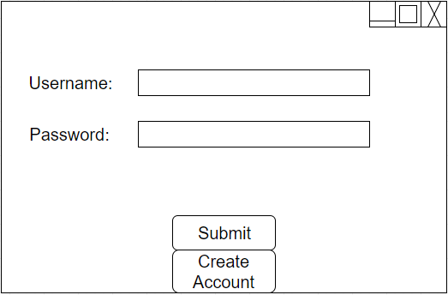

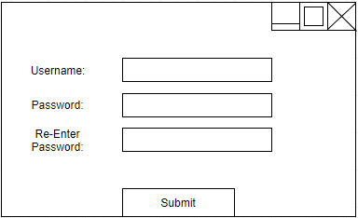

For this deliverable, we will implement the ‘Create Account’ button. This button press will bring up a new screen from which the user will enter their information for their account. This information will be sent to the model class to update the list of users so the next time the user tries to enter their information, they can successfully log in with their new credentials.

1. Describe how you will test this functionality.

To test this functionality, all that is required of the tester is to try different situations for login to make sure that each situation is handled effectively. For regular login, when the user has an account already created, you can test the functionality by first, attempting to log in with the correct username and password. Next, you can test to see how the app handles bad login attempts by trying different combinations of good usernames with bad passwords, or good passwords with bad usernames. Once each of these cases has been tested, you can be sure that the program works as intended. For the ‘Create Account’ function, simply click the button, then attempt to create an account by entering the required information. To test a failure case, try to enter a username which already exists, making sure the system does not allow for duplicate usernames.

1. Describe the responsibilities of project team members in implementing this new functionality.

Waylon will be responsible for the ‘Create Account’ button and its functionally as previously mentioned in the proposal. Andrew will be responsible for the merger of the elements added from project deliverable 1 and 2 as mentioned above as well.